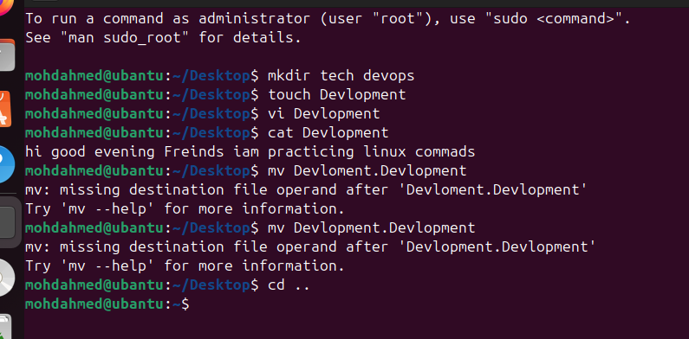

Today I practice How to create a new directory
The command’s I use for that is :
1 mkdir space directory Name tech devops
2 after that I create a folder while create a folder the command is use
Touch space folder name development
3 after that for adding a content in folder the command is use
Vi and folder name Devlopment
4 after for read and see the content in the folder the command is use that is
Cat and folder Name
5 and also use the command of present working directory
Pwd

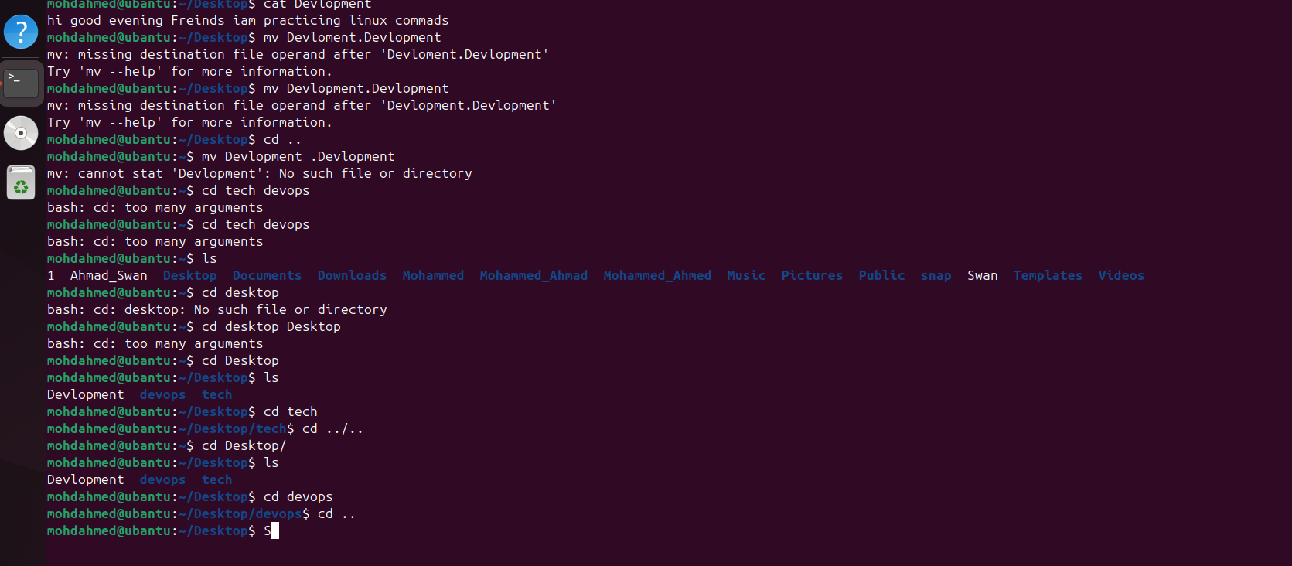

6 after I will change directory The command is use that is
Cdspace directory Name
7 And I will use command of cd.. for go back for one step

8 And I will use the Command of d../.. for Two steps back

9 And I will use ls command for list of files

10 And I use the ll command for see the all complete list of file

11 For hide a file the command I use that is mvspaceflodername.foldername

12 For unhide a file the command I use that is mvspace.folder name folder name

